**Code Execution instructions**

Before executing the code assignment.py, a copy of the disk image file which is being used in the coding, needs to be taken for two reasons:

1. To make sure that the contents of the files are not changed.
2. In case if any changes are made unintentionally or intentionally, we will have a backup to get the file content back

Before executing the code, take hash of the file



To execute the code, the path of the image file must be specified in the main of the variable fatimageFile as shown below

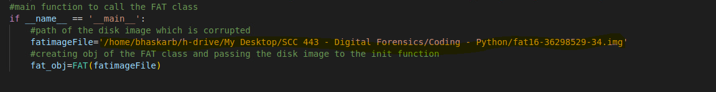

After execution of code, the folders RecoveredFiles and GoodFiles gets created in /home directory of the system and also the visual studio console displays few information as follows:

Console output:

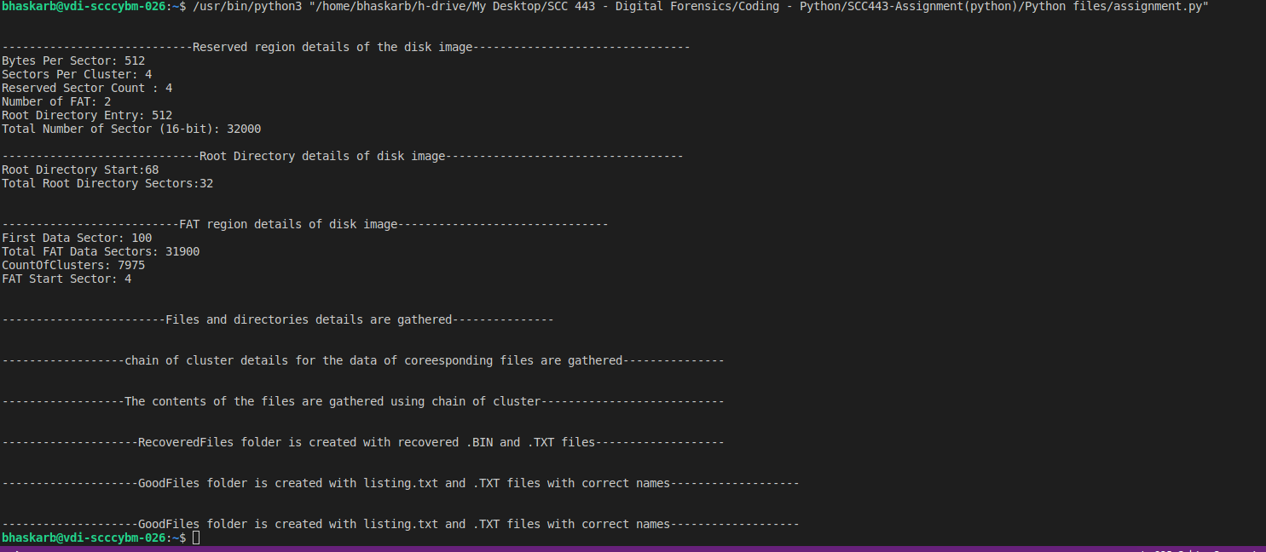

GoodFiles and RecoveredFiles are created as follows in home directory as an output of the code

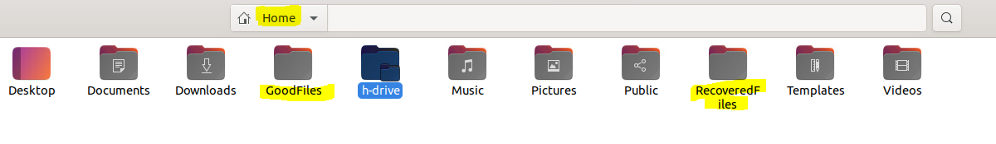

After completion of the execution, the md5 of the disk image file used in the code needs to be checked for any changes



If the md5 matches before and after execution of the code, it means that the evidence is intact and no changes has been made